Richard Hooton
“Shevington Sergeant killed by shell” from the Wigan Observer, 20th October 1917:
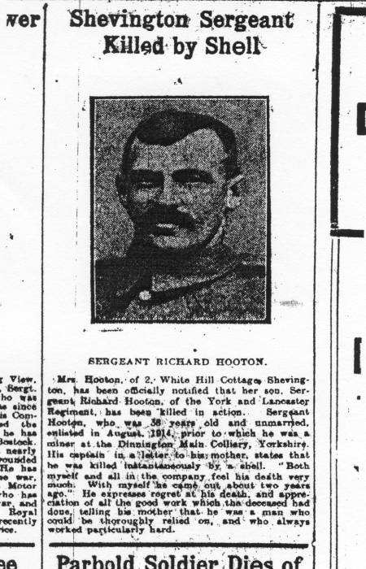
“Mrs Hooton, of 2 White Hill Cottages, Shevington, has been officially notified that her son, Sergeant Richard Hooton, of the York and Lancaster Regiment, has been killed in action. Sergeant Hooton, who was 36 years old and unmarried, enlisted in August 1914, prior to which he was a miner at the Dinnington Main Colliery, Yorkshire. His captain, in a letter to his mother, states that he was killed instantaneously by a shell. ‘Both myself and all in the company, feel his death very much. With myself he came out about two years ago.’ He expresses regret at his death, and appreciation of all the good work which the deceased had done, telling his mother that he was a man who could be thoroughly relied upon, and who always worked particularly hard.”
There is a conflict between this report and the CWGC records in which Richard is given the rank of lance corporal, 12921 of the 9th battalion, the York and Lancaster Regiment. One might imagine, from the newspaper article that the whereabouts of his body were known and that it would have been buried in an identified grave. However, Richard has no known grave, and is merely remembered at the Tyne Cot memorial, is as John Marshall. There may have been nothing left to bury. The date of his death is given as 23rd September, 1917. Richard is remembered at the Tyne Cot Memorial at Ypres, 30 miles south east of Dunkerque in Belgium, having died at Passchendaele.
Richard’s family
Richard’s mother, Mary Turner, appears to have married twice. She outlived the first husband, and may have left, or been abandoned by, the second.
In 1891 Mary was living in White Hill Lane, Shevington, and was married to James Roscoe. There were four sons, Richard and William Hooton, and James and Joseph Roscoe. Mary’s husband, William Hooton, had died and she had remarried.
Ten years later the family had moved to Hunger Hill and two daughters had been born. Step-father James was a coal miner hewer, and Richard was working as a drawer in a coal mine. William was a “farm servant in charge of cattle”.
In 1911 Mary is described as “head of the household” living in the “Farm Cottage, Standish Hall” with just the two, now grown-up, sons from the first marriage. The four children with the Roscoe surname, (now aged 23, 21, 19 and 17) and their father James, if he was alive, were living somewhere else.
However, his half-siblings are listed as his next-of-kin in his service record, along with his mother and brother William, so we assume that relationships had not totally broken down. In 1918 Mary and the brother William were living at 2, White Hill Cottage, Shevington. Richard had been a devout Catholic. (His effects, sent home to his mother, included “letters, religious book, photo, religious emblem”.)
Various aunts and uncles are specified in other records; they may be siblings of his mother or father:-
Thomas Turner, age 67, Courage Low, Wrightington
William Turner, age 65, Cat i'th'window, Standish
Margarita Winstanley, age 74, Church St, Standish
Anne Strange, Nightingale Farm, Wrightington
Alice Walsh, Aspull Moor.
Richard’s work
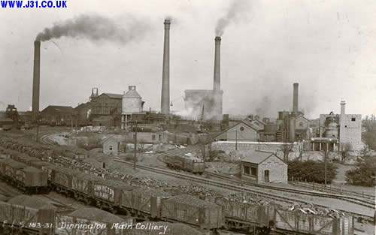
Richard had been a miner in Shevington. He must have heard that the money was better in Yorkshire, because:-

“In 1902, with advanced machinery and better way to drain and ventilate coal mines, the Dinnington Main Colliery was begun. They also had railway connection for delivery of the coal to the ever hungry industrial revolution of the time. There was a huge amount of coal under the Magnesian Limestone, but it was too difficult to reach until the new machinery arrived.
“Dinnington miners were paid better than some others in the country, . . . .
“The miners lived in Tin Town, a shanty town with corrugated iron sided houses next to the pit. This changed when the mine became lucrative and the company built stone cottages some distance from the mines for the workers and their families.
“In 1914, the Colliery Company paid two pounds to each man who would enlist to fight in World War I. Like many others in rural England at the time, they went to war as to an adventure not realizing that most, if not all, of them would never return and the world would be changed forever.” – from a history of Dinnington.
So we know that Richard went to war because the colliery paid him to do so!
What happened to Richard?
Like John Marshall, Richard died at Passchendaele. “The whole Allied front area was reclaimed land and years of shelling had destroyed the drainage and the place was a dangerous quagmire; many men and horses disappeared into the mud if they moved off the planked road and pathways. The salient was a particularly horrid place to be, being constantly probed and shelled by the Germans who held the ridge above. As a result of the constant shelling from the ridge, even some wounded left during the advances would drown in flooded shell holes or just ‘disappear’ before help could get to them.”
His service records state that he was 29 years and 2 months old and enlisted at Rotherham on 28th Aug 1914. He was 5’ 9” tall, fair complexion, blue eyes, dark brown hair, and a Roman Catholic. His eyes were not tested; he had no distinguishing marks.
“The 1/5th Battalion York & Lancaster Regiment was a Territorial Army Unit that was mobilised in Rotherham [Drill Hall] August 1914 as part of the 3rd West Riding Brigade, West Riding Division. Moved to France in 1915 the formation became 148th Brigade, 49th Division.” (From a website.)
Richard was severely reprimanded for “falling in late” on 3 occasions. 2nd Nov 1915 “severely reprimanded for highly improper conduct while on active service”.
8th May 1915 treated for herpes of lip (i.e. cold sore) “painted with argentum metallicum” (colloidal silver, used as a remedy for cold sores.) Sustained gunshot wound to buttock and head 3rd July 1916.
Went to France (again?) on 3rd Jan 1917. 10th Aug 1917 admitted to field hospital with tonsillitis. He never retuned home.

